
SECJ2203: Software Engineering

System Documentation (SD)

Project Title

Version X

Date

Faculty of Computing

Prepared by: <Team name>

Revision Page
- Overview
Describe the content of the current version of SD (see below – the note in red).

- Target Audience
State the targeted audience for the SD.

- Project Team Members
List the team members in a table by stating their roles and the status for each assigned task e.g. by sections for this SD version (complete, partially complete, incomplete). If the assigned tasks are not done and have been assigned to other team members, state accordingly.
Member Name | Role | Task | Status

- Version Control History
Version | Primary Author(s) | Description of Version | Date Completed
1.0 | Team leader 1 (Full Name) | Completed Chapter X, Section… | dd/mm/yyyy
…

Note: The title page should show the latest version. For your first submission (Assignment 2), the version should be 1.0, then 2.0 for Assignment 3, and then 3.0 for Assignment 4. Primary author(s) could be the team leaders who should compile all materials for the purpose of SD submission. [remove this note in red texts and the examples in the table above]

Note:
This System Documentation (SD) template is adapted from IEEE Recommended Practice for Software Requirements Specification (SRS) (IEEE Std. 830-1998), Software Design Descriptions (SDD) (IEEE Std. 1016­1998 1), and Software Test Documentation (IEEE Std. 829-2008) that are simplified and customized to meet the need of SECJ2203 course at Faculty of Computing, UTM. Examples of models are from Arlow and Neustadt (2002) and other sources stated accordingly.

Table of Contents
1 | Introduction |  |  | 1
 | 1.1 | Purpose |  | 1
 | 1.2 | Scope |  | ?
 | 1.3 | Definitions, Acronyms and Abbreviations |  | ?
 | 1.4 | References |  | ?
 | 1.5 | Overview |  | ?
2 | Specific Requirements |  |  | ?
 | 2.1 | User characteristics
 | 2.2 | System Features
 | 2.3 | Use Case Details
 |  | 2.3.1 | UC001: Use Case <Name of Use Case 1>
 |  |  | Use Case Specification of UC001
 |  |  | Activity Diagram of UC001
 |  |  | System Sequence Diagram of UC001
 |  | 2.3.2 | UC002: Use Case <Name of Use Case 2>
 |  |  | Use Case Specification of UC002
 |  |  | Activity Diagram of UC002
 |  |  | System Sequence Diagram of UC002
 |  | 2.3.n | UCn: Use Case <Name of Use Case n>
 |  |  | Use Case Specification of UC00n
 |  |  | Activity Diagram of UC00n
 |  |  | System Sequence Diagram of UC00n
 | 2.4 | Performance and Other Requirements
 | 2.5 | Design Constraints

3 | Architectural Rationale |  |  | ?
 | 3.1 | Architectural Style and Rationale
4 | Architectural Views |  |  | ?
 | 4.1 | Use Case View
 | 4.2 | Implementation View
 | 4.3 | Logical View
 | 4.4 | Process View
 | 4.5 | Physical/ Deployment View
5 | Data Design |  |  | ?
 | 5.1 | Data Dictionary
 |  | 5.1.1 Entity: <First Entity>
 |  | 5.1.2 Entity: <Second Entity>
6 | User Interface Design |  |  | ?
 | 6.1 | Screen Images
7 | Traceability |  |  | ?
8 | Test Cases |  |  | ?
 | 8.1 | TC001: Test <Name of Package 1> Subsystem: <Name of Use Case (UC001)>
 |  | 8.1.1 | TC001_01: Test <Scenario of Sequence Diagram 1 (SD001)>
 |  | 8.1.2 | TC001_02: Test <Scenario of Sequence Diagram 2 (SD002)>
 | 8.2 | TC002: Test <Name of Package 2> Subsystem: <Name of Use Case (UC002)>
 | 8.3 | TC003: Test <Name of Package 3> Subsystem: <Name of Use Case (UC003)>
 | Appendices
 | Appendix A: Traceability Matrix

Update this table of content accordingly

Introduction
The following sections of the System Documentation (SD) should provide the details of the entire document comprising System Requirements Specification (SRS), System Design Document (SDD), and System Testing Document (STD). Remove the notes in red texts when submitting including these notes.

  - Purpose
This subsection should:
- Delineate the purpose of the SD;
- Specify the intended audience for the SD.

[The SD describes…]

  - Scope
This subsection should:
- Identify the software product(s) to be produced by name (e.g., Online Learning System, Emotion Chatbot Anlayzer, etc.);
- Explain what the software product(s) will, and, if necessary, will not do;
- Describe the application of the software being specified, including relevant benefits, objectives, and goals;

[The software product is…]

  - Definitions, Acronyms and Abbreviation
This subsection should provide the definitions of all terms, acronyms, and abbreviations used in the SD.

[Definitions of all terms, acronyms and abbreviations used are to be defined here.]
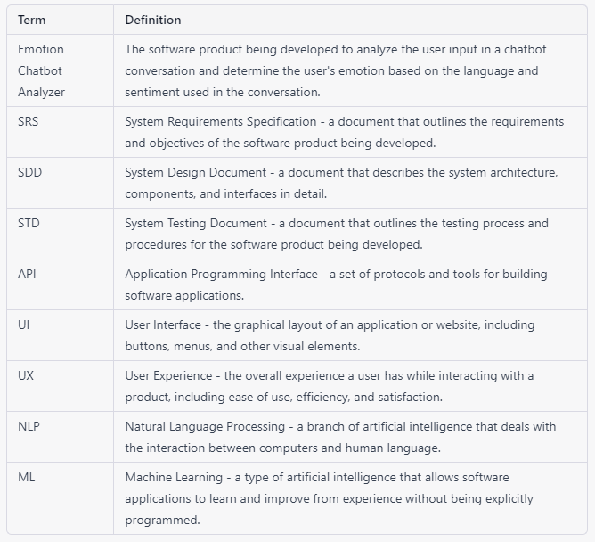

  - References
This subsection should:
- Provide a complete list of all documents referenced elsewhere in the SD;
- Identify each document by title, report number (if applicable), date, and publishing organization;
- Specify the sources from which the references can be obtained.

[Specify a complete list of references using a standardized reference format]

  - Overview
This subsection should:
- Describe what the rest of the SD contains;
- Explain how the SD is organized.

[Give an overview of the content of this SD document.]

Specific Requirements
This section of SD serves as the SRS that should contain all the software requirements to a level of detail sufficient to enable designers to design a system to satisfy those requirements, and testers to test that the system satisfies those requirements. Throughout this section, every stated requirement should be externally perceivable by users, operators, or other external systems. These requirements should include at a minimum a description of every input (stimulus) into the system, every output (response) from the system, and all functions performed by the system in response to an input or in support of an output.

  - User characteristics
This should specify the following:
In an SRS, the user characteristics section describes the intended users of the system and their characteristics, such as their technical expertise, knowledge, and physical abilities. This section is important because it provides the development team with a clear understanding of whom the system is designed for, and helps to ensure that the system is developed to meet the needs of its intended users.
Example. Describe how the system will interact with its users.
The "Emotion Chatbot Analyzer" software will be used by two main types of users: UTM students and UTM counselors.
2.1.1 UTM Students
- The UTM students who will use the software are expected to have basic computer skills, including familiarity with web-based applications.
- They may have varying levels of emotional intelligence and may experience a wide range of emotional states, from mild stress to severe anxiety or depression.
- Some students may be reluctant to seek counseling or may not have access to professional ccounseling services, making the chatbot a valuable resource for emotional support and guidance.
2.1.1 UTM Counsellors
- The UTM counsellors who will use the software are expected to have professional training and experience in counselling and psychology.
- They may have varying levels of technical expertise, but will receive training on how to use the software.
- They will use the software to access student emotion records and provide counselling services to students as needed.
- Both types of users will be required to provide personal information such as name and email address in order to register for the software. The software will be designed with privacy and security measures in place to protect user information.

  - System Features
Specify the product perspective.

Example.
The Emotion Chatbot Analyzer is a software system that operates on mobile devices, including both Android and iOS operating systems. The system provides a means for UTM students to better manage their emotional health and at the same time simplifies the process of seeking emotional support from UTM counselors The system also implemented a real-time cloud-based database for better user experiences.

Specify the product module and function..
Include use case diagram here – see an example of Emotion Chatbot Analyzer below
Then, provide the description of each module and function using a table.

Example.
The system features is illustrated in Figure X.X below. The detail description of each module and functions is tabulated in Table X.X.

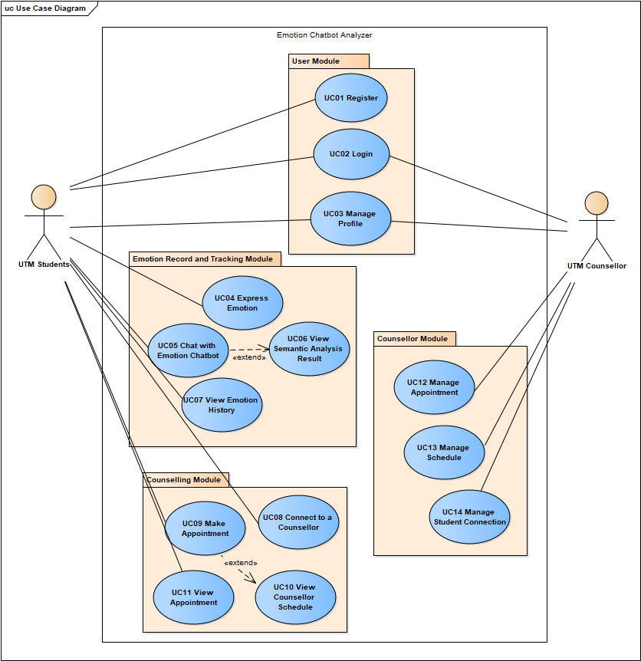
Figure X.X: Use Case Diagram for <Name of the System>

Table X.X: Description of Module and Functions for <Name of the System>
Module | Function | Description
User Module | UC01 – Register | This use case allows students to sign up as a user for the mobile application.

[Include domain model i.e. class diagram without the operation part – only attributes without details on visibility and type, explain each class and its attributes including the relationships among the classes, see the example.]
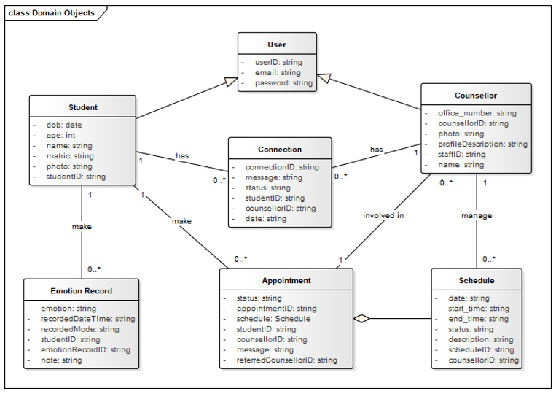
Figure X.X: Domain Model for <Name of the System>

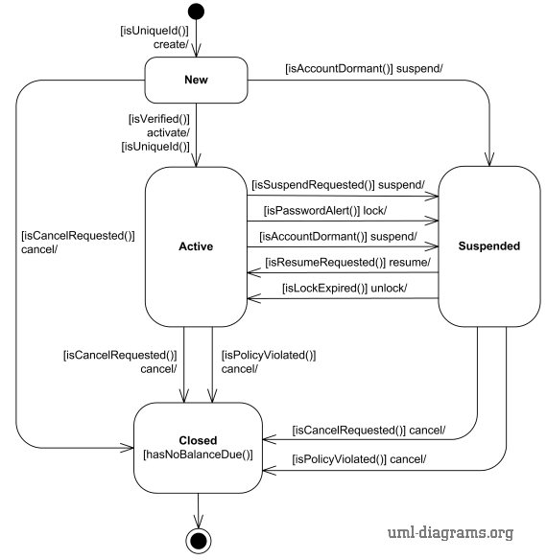
Figure X.X: State Diagram for <Name of the System>
  - Use Case Details

    - UC001: Use Case <Name of Use Case 1>
[Provide code for each use case such as UC001 and so on… Include Use Case Description for each use case as in the example below. If there are any alternative flows, add the rows accordingly. Otherwise, just remove the rows. Ensure each use case has its own unique ID and the name of the heading above corresponds to the name of use case in the use case diagram (refer to Figure X.X). Different scenarios of a use case require separate use case descriptions.]

Table X.X: Use Case Description for <Name of Use Case>
Use case: <Name of Use Case>
ID: UCxxx
Actors:
Preconditions:

Flow of events:
1.
2.
…

Postconditions:

Alternative flow n:

Postconditions:

Exception flow (if any):

[Include sequence diagram and activity diagram for each respective user case. See example below. May consider including different scenarios in different diagrams, if necessary, to avoid clutter.]

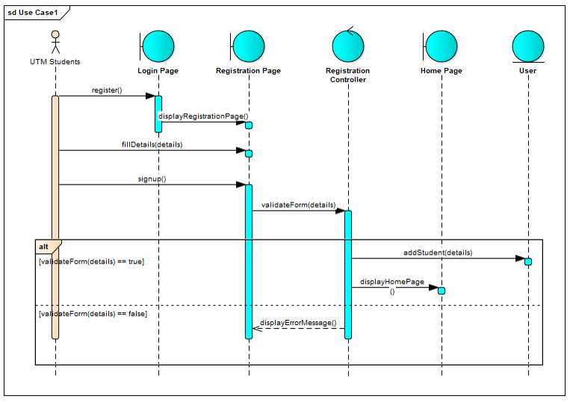
Figure X.X: Sequence Diagram for <Name of Use Case/Scenario if more than one scenario>

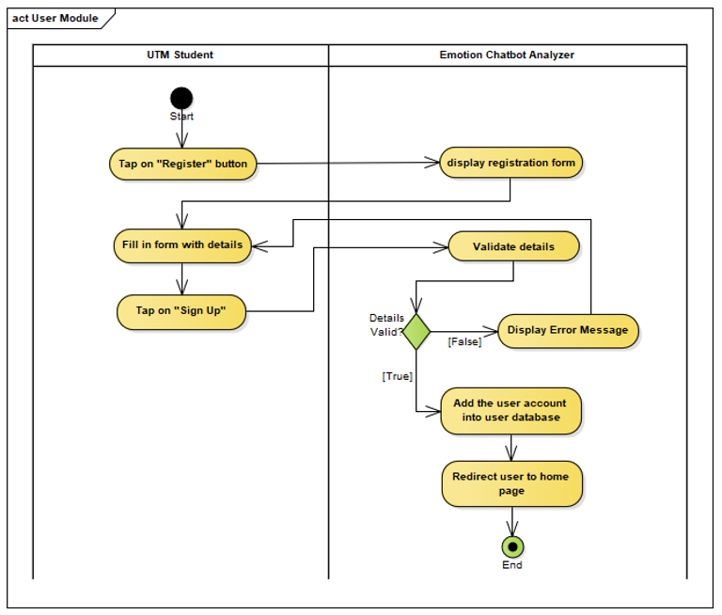
Figure X.X: Activity Diagram for <Name of Use Case/Scenario if more than one scenario>

    - UC002: Use Case <Name of Use Case 2>

    - UCn: Use Case <Name of Use Case n>
…

  - Performance and Other Requirements
Non-functional requirements are the requirements that describe how the system should behave or operate, rather than what it should do. They address the characteristics or qualities of the system, such as its usability, reliability, performance, security, maintainability, and compatibility. Non-functional requirements are important to write in the SD because they help ensure that the system meets the stakeholders' needs and expectations.The ISO/IEC/IEEE 29148 standard suggests that non-functional requirements should be specified under three main categories: Software System Attributes, Performance and Other Requirements.

Example of Software System Atrributes are as follows:
Software system attributes define the overall qualities or characteristics of the software. These attributes are the foundation on which the software is built, and they include the following:
- Usability: The ease with which users can interact with the system.
- Reliability: The ability of the system to perform its functions correctly and consistently.
- Maintainability: The ease with which the system can be modified, repaired, and enhanced.
- Portability: The ability of the system to run on different hardware and software platforms.
- Compatibility: The ability of the system to work with other systems and components.

Example of Performance is as follows:
Performance requirements define the system's capability to respond to user requests and handle data in a timely manner. These requirements include the following:
- Response Time: The time it takes for the system to respond to a user request.
- Throughput: The number of requests the system can handle in a given period of time.
- Capacity: The maximum number of users or amount of data that the system can handle.
- Availability: The percentage of time the system is operational and accessible to users.

Example of Other Requirements is as follows:
Other requirements refer to any non-functional requirements that do not fit under the categories of software system attributes or performance. These requirements include the following:
- Security: The protection of the system and its data from unauthorized access and malicious attacks.
- Safety: The ability of the system to operate safely without causing harm to users or the environment.
- Legal and Regulatory: Compliance with laws, regulations, and standards.
- Environmental: The impact of the system on the environment.

  - Design Constraints
Explain any constraints imposed by the organization where the software product will be used such as the system must adhere to certain organizational standard and other external non-functional requirements.

Example is as follows:
Environmental constraints: These constraints relate to the physical environment in which the system will operate, such as temperature, humidity, and lighting conditions. An example of an environmental constraint is: "The system must be designed to operate in temperatures ranging from 0°C to 40°C."

Hardware constraints: These constraints relate to the specific hardware components that will be used in the system, such as processors, memory, and storage. An example of a hardware constraint is: "The system must be designed to run on a minimum of 8GB of RAM."

Security constraints: These constraints relate to the security requirements for the system, such as data encryption, authentication, and access control. An example of a security constraint is: "The system must be designed to encrypt all sensitive user data using AES-256 encryption."

Compatibility constraints: These constraints relate to the compatibility requirements for the system, such as compatibility with specific software or hardware components. An example of a compatibility constraint is: "The system must be designed to be compatible with Windows 10 operating system."

Performance constraints: These constraints relate to the performance requirements for the system, such as response time, throughput, and capacity. An example of a performance constraint is: "The system must be designed to support a maximum of 1000 concurrent users with a response time of less than 5 seconds."

Architectural Rationale
This section of the SD serves as part of SDD that should describe the architectural style and the rationale or justification of your selection. The component and subsystem diagram should also be included.

  - Architecture Style and Rationale
State your chosen architectural style and the rationale of choosing that particular style.
State here

Architectural Views
This section of the SD serves as part of SDD that should describe the architectural views of the system based on the framework developed by Philippe Kruchten.The views consist of scenario view, logical view, process view, development view and physical (deployment) view as shown in Figure 4.1. Each views have iits own usage and models or diagram to represent it as shown in Table 4.1

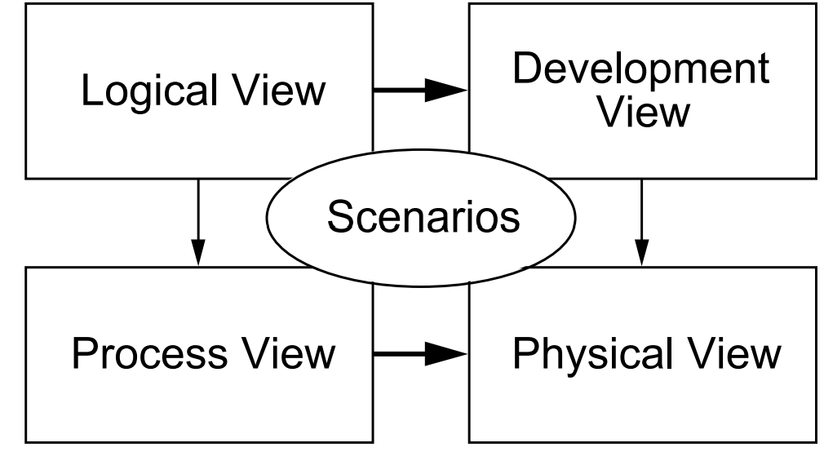
Figure 4,1 – Architecttural Views

Table 4.1
Architectural Views | Description | Diagrams used
Use Case View | The elements in the four views are shown to work together seamlessly by the use of a small set of important scenarios in a general use cases | Use Case Diagram
Logical View | shows the key abstractions in the system as objects or object classes | Class Diagram
Process | The process view deals with the dynamic aspects of the system, explains the system processes and how they communicate, and focuses on the run time behavior of the system. | Sequence Diagram
Development (or Implementation) View | shows how the software is decomposed for development | Component Diagram  Package Diagram
Physical (or Deployment) View | shows the system hardware and how software components are distributed across the processors in the system | Deployment DIagram

  - Use Case View
This view serves as a unifying thread across the remaining three views, ensuring consistency and completeness. It represents the functional requirements and ties the views together using real-world scenarios or use cases.

[Include use case diagram here – see example of Online Shopping as in Figure 4.2, source: https://www.uml-diagrams.org/index-examples.html]

Figure 4.2: Use Case Diagram for <Name of the System>

  - Implementation View
This view shows the organization of the system’s software modules in its development environment. It focuses on how the system is decomposed into components for implementation.

This is a high-level overview of how responsibilities of the system were partitioned and then assigned to subsystems. Identify each high-level subsystem and the roles or responsibilities assigned to it. Describe how these subsystems collaborate with each other in order to achieve the desired functionality. Do not go into too much detail about the individual subsystem. The main purpose is to gain a general understanding of how and why the system was decomposed, and how the individual parts work together. Provide a diagram showing the major subsystems and data repositories and their interconnections. Describe the diagram clearly.

[Include an architecture diagram here based on the architecture style you have chosen Figure 4.3– see example of the three-layer internet system from Satzinger (2011).]
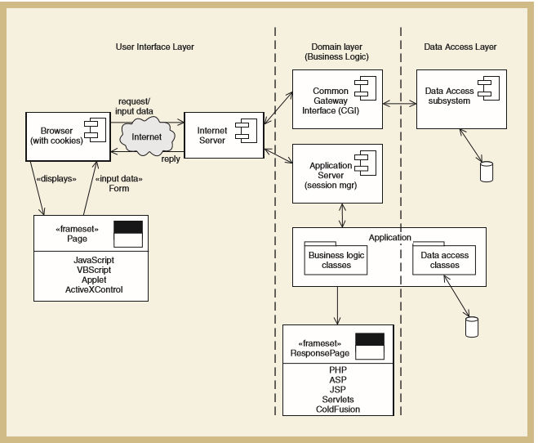
Figure 4.3: Architecture Diagram of <Name of the System>

Package diagrams denote which classes work together as a subsystem.

Include the overall package diagram of your system here. [Example package diagram for a Sale System adapted from Satzinger (2011)] Indicate the navigation visibility based on the dependency among classes in the design class diagram. If the diagram is too cluttered, simplify the classes by showing the class name only without showing the attributes and methods. The details can be shown in the following class diagram sub-section for respective subsystem/package.

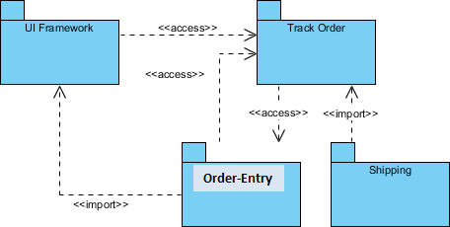
Figure 4.4: Package Diagram for <Name of the System>

Include all the individual package diagram based on the overall package diagram Figure 4.4.

The given example includes the view, domain, and data access layer in respective packages. Organise subsystem/package according to the chosen architectural style. Note that if you choose model-view-controller (MVC) or other architectural patterns, then the packages should follow the selected pattern.

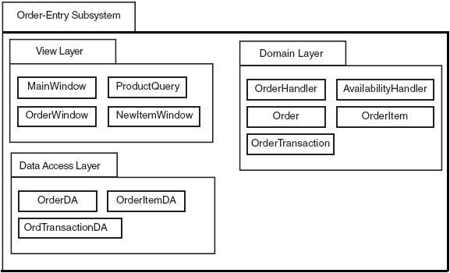
Figure 4.4: Package Diagram for <Order-Entry> Subsystem

…
Figure 4.5: Package Diagram for <Track Order> Subsystem

…
Figure 4.6: Package Diagram for <Shipping> Subsystem

…

…

  - Logical View
This view focuses on the system's structure from the perspective of the developer or software designer. It represents the key abstractions in the system, often modeled as objects or object classes in object-oriented design.

For each subsystem/package, there must be ONE class diagram and sequence diagram(s) based on how many use cases you have in the subsystem/package. For this veie, Include class diagram to represent all classes in the respective subsystem/package.

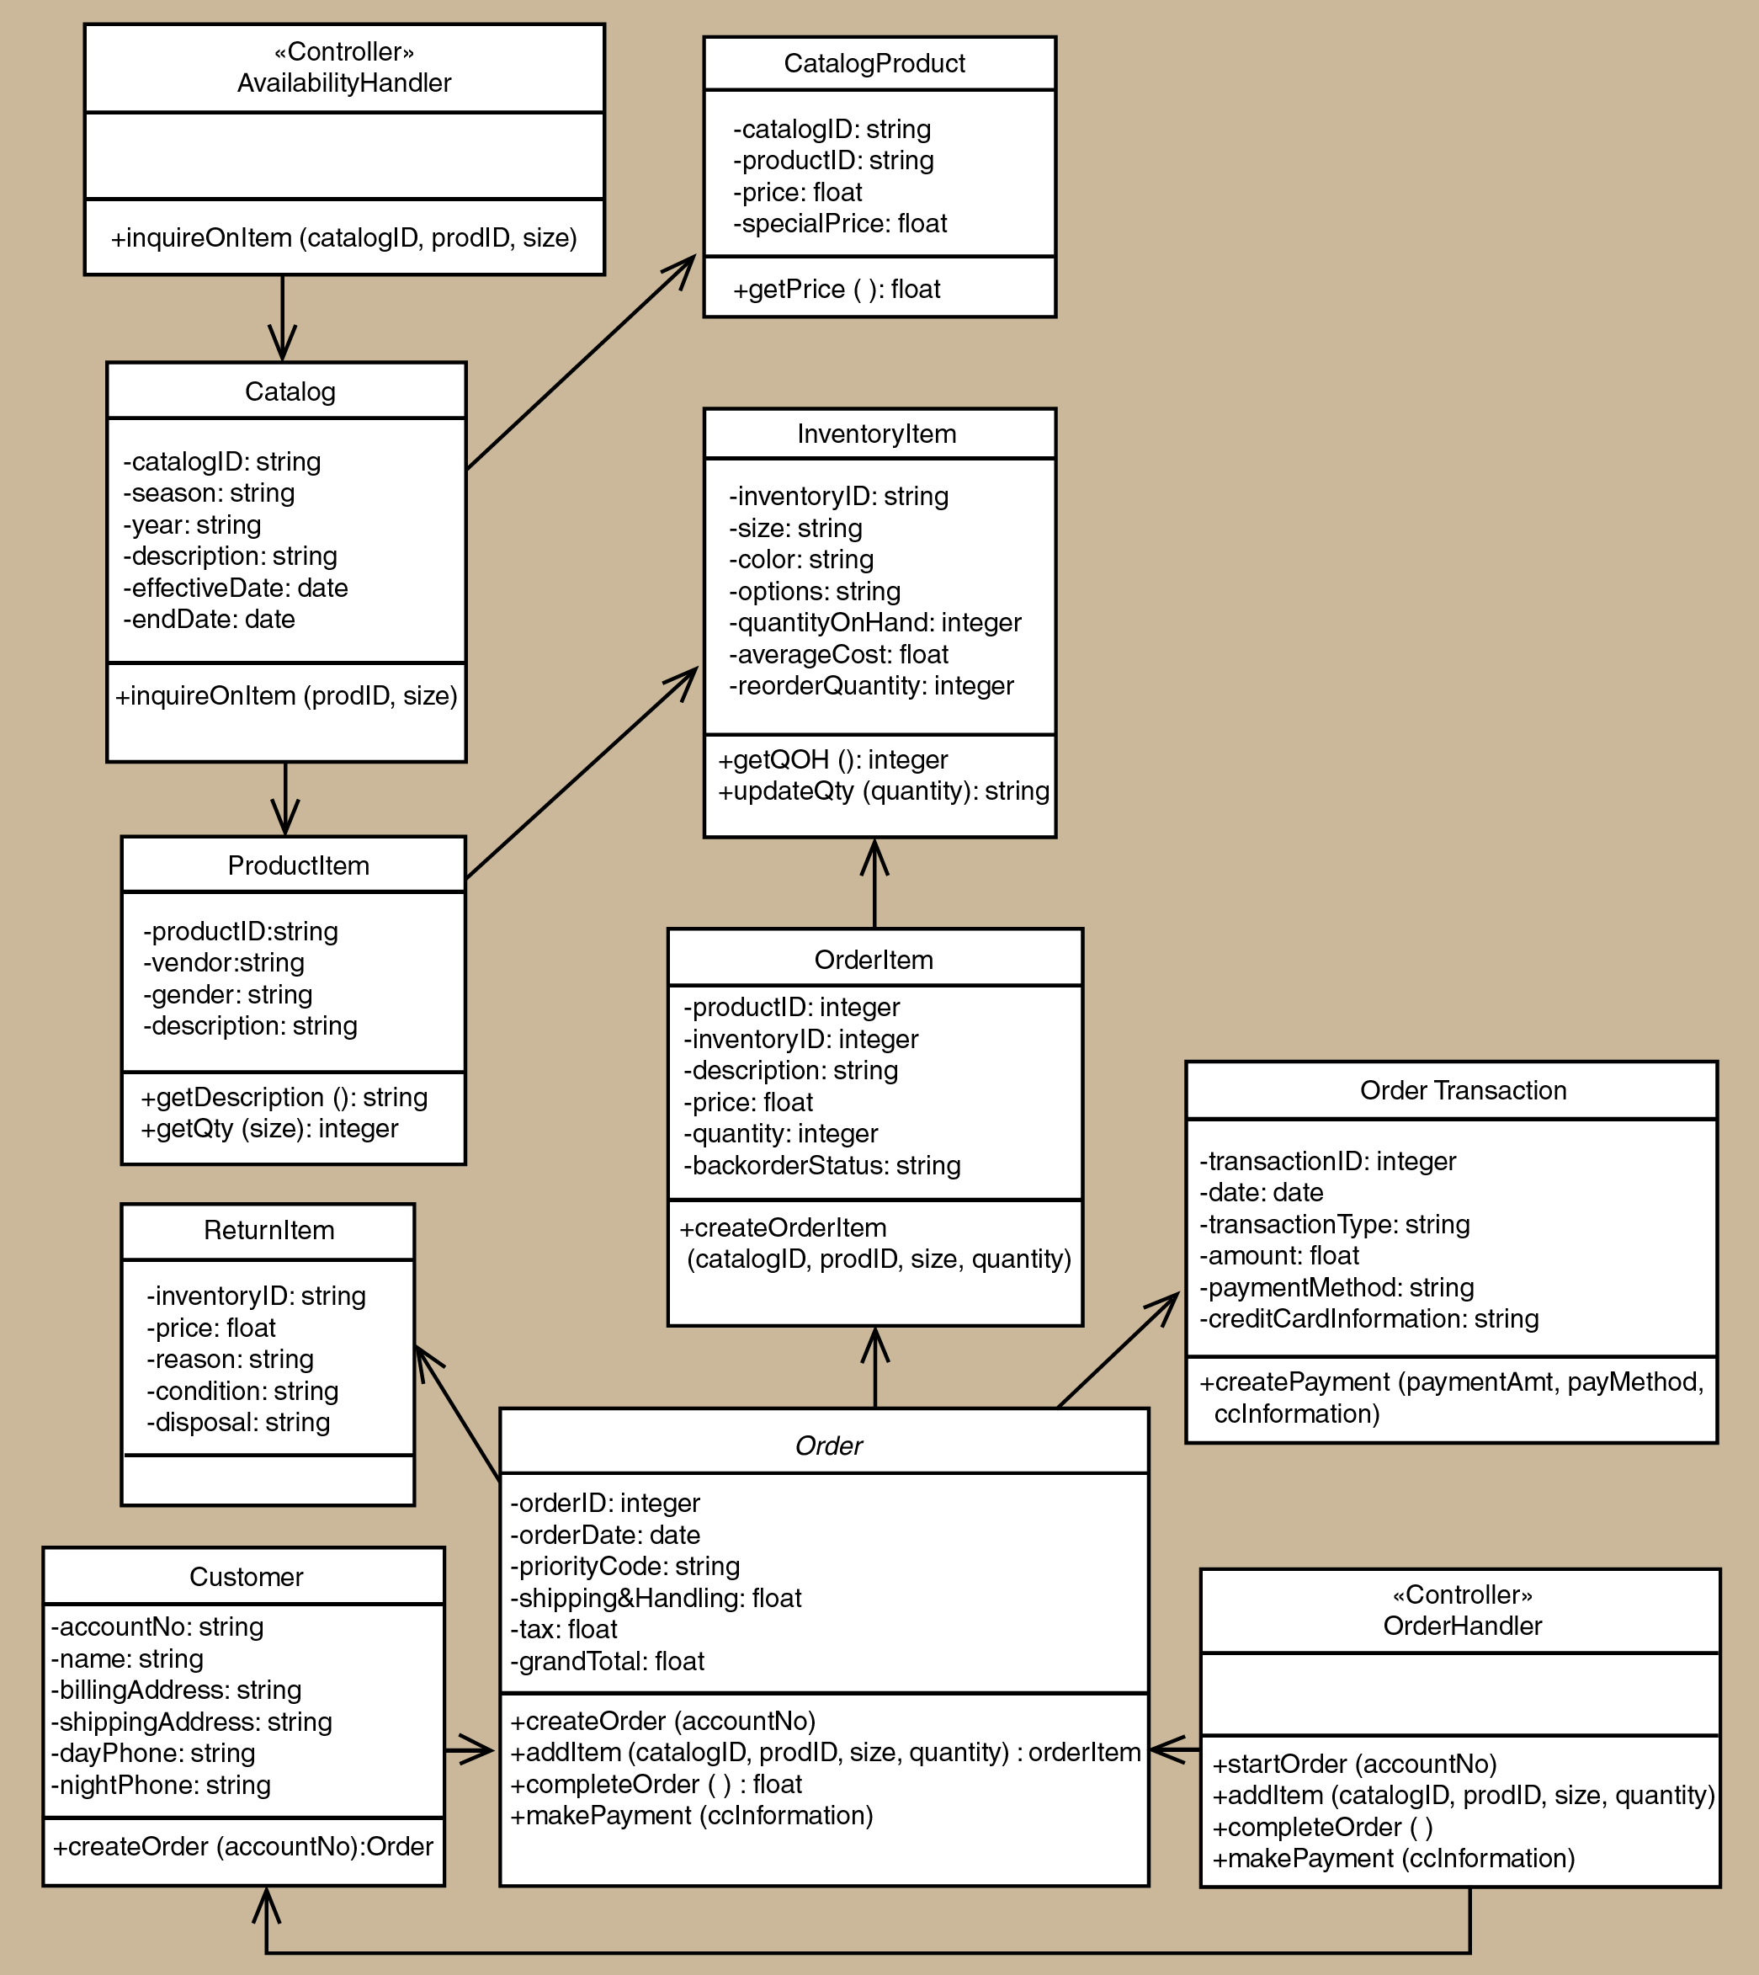
Figure 4.7: Class diagram for <Order-Entry> Subsystem

…
Figure 4.8: Class Diagram for <Track Order> Subsystem

…
Figure 4.9: Class Diagram for <Shipping> Subsystem

…

…

  - Process View
This view iIlustrates the dynamic aspects of the system, specifically how its components interact at runtime. It demonstrates how the system is composed of processes that communicate with each other.

Include sequence diagram for appropriate use case in your subsystem package. Use branching in the sequence diagram to combine alternate flow in the same sequence diagram. If the diagram is cluttered, consider a new sequence diagram for the respective scenario/alternate flow.

In these examples only sequence diagram Create New Phone Order Scenario and Cancel an Order Scenario are shown. Include the final sequence diagram that comprises view layer, controller, and its problem domain (entity) and data access layer. Provide a unique code for each scenario of sequence diagram to be used in Section 7: Requirements Matrix/User Story Mapping. If you have only one scenario, then you only need one sequence diagram.

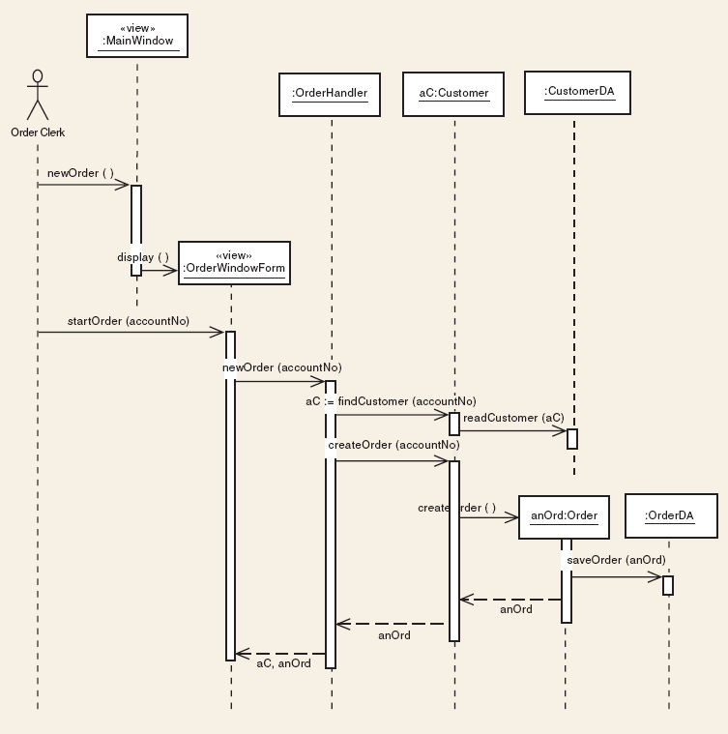
Figure 4.10: SD001 Sequence Diagram for <Create New Phone Order Scenario>

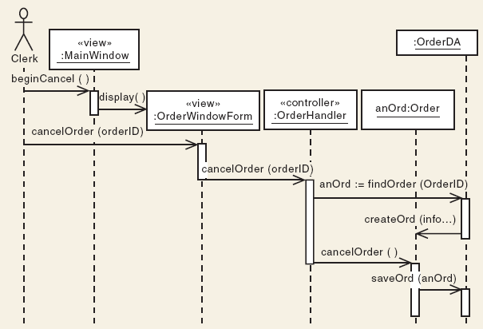
Figure 4.11: SD002 Sequence Diagram for <Cancel an Order scenario>

  - Physical/ Deployment View
This view describes how the software system is physically deployed on the hardware infrastructure. It represents the physical architecture of a system. It shows how the system’s software components are deployed across hardware nodes and their interconnections. Deployment diagrams are used to visualize the relationships between software and hardware elements in a system, helping to ensure proper deployment and performance optimization.

Include the deployment diagram for the components of your system here. Show the physical hardware components (e.g., servers, processors, devices, or cloud infrastructure) on which the system is deployed.

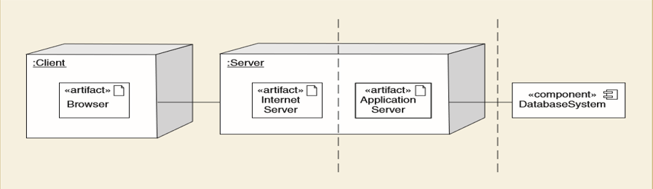
Figure 4.12: Deployment diagram for Internet-based System

Data Design
Explain how the information domain of your system is transformed into data structures. Describe how the major data or system entities are stored, processed, and organized. List the database(s) or data storage items. For a small system, there is normally only one database. It consists of all the tables in which for object-oriented they are classes/objects as also stated in the domain model. Use table for the listing.
The major data or systems entities are stored into a relational database named as…, processed and organized into n entities as listed in Table 5.1.

Table 5.1: Description of Entities in the Database
No. | Entity Name | Description

  - Data Dictionary
Alphabetically list the system entities or major data along with their types and descriptions (class/object, attributes). Focus on classes in domain layer; omit the controller/handler class. Use tables for easy listing as shown below.

    - Entity: <First Entity>
Attribute Name | Type | Description

    - Entity: <Second Entity>
Attribute Name | Type | Description

User Interface Design
Describe the functionality of the system from the user’s perspective. Explain how the user will be able to use your system to complete all the expected features and the feedback information that will be displayed for the user.
The interface includes…

  - Screen Images
Display screenshots showing the interface from the user’s perspective. These can be drawn using an automated drawing tool. Just make them as accurate as possible. Organise the images by subsystem/package.
Insert the screenshot here

Figure 6.1: Interface for <State the Feature/Function>

Traceability
(FOR PLAN-DRIVEN)
Provide a cross-reference that traces components and data structures to the requirements in the SD (Section 2).
Use a tabular format to show which system components (sequence diagram vs. class) satisfy each of the functional requirements represented as use cases. Refer to the functional requirements by the numbers/codes given to each use case in Chapter 2. Examples of traceability to ease tracing of related omponents (sequence diagram vs. class) for each use case in respective subsystem/package are as listed as in Table 7.1. The sequence diagrams for each use case vs. corresponding classes (entities).

Table 7.1: Requirement Matrix
Package, UC , Sequence Diagram /EntityClass | Customer |  | Order | Catalog | CatalogProduct | ProductItem | OrderItem | ReturnItem | InventoryItem | …
P001, UC001, SD001 |  | X | X
P001, UC001, SD002 |  |  | X
P002, UC002, SD003 |  |  |  | X | X
P003, UC003, SD004 |  |  |  |  |  | X | X | X | X
P004, UC004, SD005 |  |  | X |  |  |  |  |  | X
…

Test Cases
This is a numbered list of tests. Use tables to group similar tests. For each test, specify:
- Test ID and name
- Additional description if test name is not descriptive enough
- The input data
- The expected output data
- The actual output data (not in the scope of this course – leave blanks)
- Result: pass or fail (not in the scope of this course – leave blanks)

  - TC001: Test <Name of Package 1> Subsystem: <Name of Use Case (UC001)>
List all test cases before providing the details for each under each package/subsystem and use case.
This test contains the following test cases:
- TC001_01: Test <Scenario of sequence diagram1 (SD001)>
- TC001_02: Test <Scenario of sequence diagram2 (SD002)>
- …

    - TC001_01: Test <state scenario of sequence diagram1 (SD001)>
Provide the details for each test case in the test case template (Excel). For the scope of this course, leave blanks for the columns on actual results and pass/fail status. See the example below for better understanding. If there are alternate and exception scenarios, include respective test cases under this sub-section also.
This test contains the following alternate and exception scenarios (if any):
- TC001_01_01: Test <alternate scenario1 of sequence diagram1 (SD001)>
- TC001_01_02: Test <exception scenario1 of sequence diagram1 (SD001)>
- …

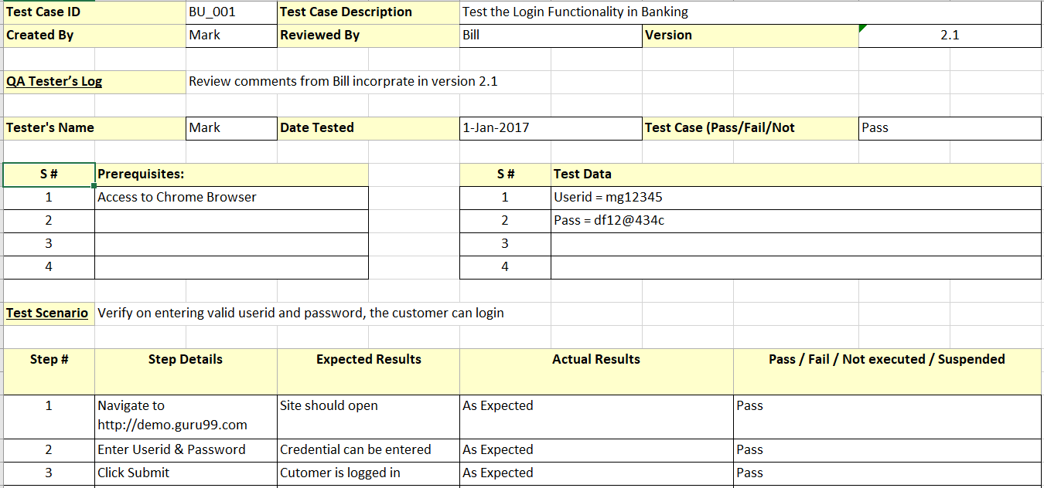

    - TC001_02: Test <Scenario of sequence diagram2 (SD002)>
Provide the details for this test case.
    - TC001_n: Test <Scenario of sequence diagram n (…)>
Provide the details for this test case.
  - TC002: Test <Name of Package 2> Subsystem: <Name of Use Case (UC002)>
List all test cases before providing the details for the second use case in module1. Include the sub-sections accordingly.
This test contains the following test cases:
- TC002_01: Test <Scenario of sequence diagram4 (SD004)>
- TC002_02: Test <Scenario of sequence diagram5 (SD005)>
- …

  - TC003: Test <Name of Package 3> Subsystem: <Name of Use Case (UC003)>
List all test cases before providing the details for the first use case in module2. Include the sub-sections accordingly.
This test contains the following test cases:
- TC003_01: Test <Scenario of sequence diagram6 (SD006)>
- TC003_02: Test <Scenario of sequence diagram7 (SD007)>
- …

Appendix A: Traceability Matrix

Test Case ID | Use Case ID/  Sequence Diagram ID | Package ID
TC001 for <Name of Package 1> Subsystem  - TC001_01  - TC001_02 | UC001  - SD001  - SD002 | P001
TC002 for <Name of Package 2> Subsystem  - TC002_01  - TC002_02 | UC002  - SD004  - SD005 | P001
TC003 for <Name of Package 3> Subsystem  - TC003_01  - TC003_02 | UC003  - SD006  - SD007 | P002
…

